Week of 11/4/15

 | Monday | Tuesday | Wednesday | Thursday | Friday
Standards | Teacher planning day | Election day | (7.NS.A.2)  Understand that multiplication is extended from fractions to rational numbers by requiring that operations continue to satisfy the properties of operations, particularly the distributive property, leading to products such as (-1)(-1) = 1 and the rules for multiplying signed numbers. Interpret products of rational numbers by describing real-world contexts. | (7.NS.A.2)  Understand that multiplication is extended from fractions to rational numbers by requiring that operations continue to satisfy the properties of operations, particularly the distributive property, leading to products such as (-1)(-1) = 1 and the rules for multiplying signed numbers. Interpret products of rational numbers by describing real-world contexts. | (7.NS.A.2)  Understand that multiplication is extended from fractions to rational numbers by requiring that operations continue to satisfy the properties of operations, particularly the distributive property, leading to products such as (-1)(-1) = 1 and the rules for multiplying signed numbers. Interpret products of rational numbers by describing real-world contexts.
Learning Targets |  |  | - I can recognize that division is the reverse process of multiplication and that integers can be divided provided the divisor is not zero. | I can convert positive decimals to fractions and fractions to decimals and understand that decimals specify points on the number line by repeatedly subdividing intervals into tenths | I can interpret word problems and convert between fraction and decimal forms of rational numbers.
Plans  (Include Instructional Method, Strategies, and Activities) |  |  | - Opener  - Finish Eureka Lesson 12  - Problem Set  - Math Drills for fluency in multiplication and division.  - Exit Ticket | - Opener  - Complete Eureka Lesson 13  - Problem Set  - Exit Ticket | - Opener  - Complete Eureka Lesson 14  - Problem Set  - Exit Ticket
Assessments  (Formative and Summative) |  |  | Students determine whether or not various representations of the quotient of two integers are equivalent.  1. Mrs. McIntire, a seventh grade math teacher, is grading papers. Three students gave the following responses to the same math problem:  Student one: 1−2  Student two: −(12)  Student three: −12  On Mrs. McIntire’s answer key for the assignment, the correct answer is −0.5 . Which student answer(s) is (are) correct? Explain.  2. Complete the table below. Provide an answer for each integer division problem and write a related question using integer multiplication.  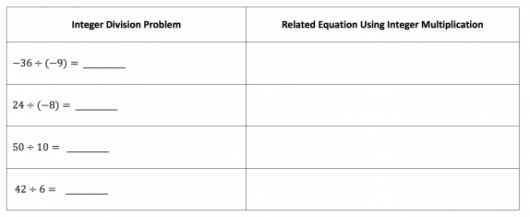 | 1. Write 3.0035 as a fraction. Explain your process.  2. This week is just one of 40 weeks that you spend in the classroom this school year. Convert the fraction 140 to decimal form | 1. What is the decimal value of 4/11?  2. How do you know that 4/11 is a repeating decimal?  3. What causes a repeating decimal in the long division algorithm?
Vocabulary |  |  | - Multiply  - Divide  - Integer  - Positive  - Negative  - Repeated addition  - Divisor  - Factor  - Decimal  - Product  - Quotient  - Subdivide  - Interval | - Multiply  - Divide  - Integer  - Positive  - Negative  - Repeated addition  - Divisor  - Factor  - Decimal  - Product  - Quotient  - Subdivide  - Interval | - Multiply  - Divide  - Integer  - Positive  - Negative  - Repeated addition  - Divisor  - Factor  - Decimal  - Product  - Quotient  - Subdivide  - Interval
Homework |  |  | Finish Problem Set | Finish Problem Set | Finish Problem Set

