Week of 10/26/15

 | Monday | Tuesday | Wednesday | Thursday | Friday
Standards | (7.NS.A.2)  Understand that multiplication is extended from fractions to rational numbers by requiring that operations continue to satisfy the properties of operations, particularly the distributive property, leading to products such as (-1)(-1) = 1 and the rules for multiplying signed numbers. Interpret products of rational numbers by describing real-world contexts. | (7.NS.A.2)  Understand that multiplication is extended from fractions to rational numbers by requiring that operations continue to satisfy the properties of operations, particularly the distributive property, leading to products such as (-1)(-1) = 1 and the rules for multiplying signed numbers. Interpret products of rational numbers by describing real-world contexts. | (7.NS.A.2)  Understand that multiplication is extended from fractions to rational numbers by requiring that operations continue to satisfy the properties of operations, particularly the distributive property, leading to products such as (-1)(-1) = 1 and the rules for multiplying signed numbers. Interpret products of rational numbers by describing real-world contexts. | (7.NS.A.2)  Understand that multiplication is extended from fractions to rational numbers by requiring that operations continue to satisfy the properties of operations, particularly the distributive property, leading to products such as (-1)(-1) = 1 and the rules for multiplying signed numbers. Interpret products of rational numbers by describing real-world contexts. | (7.NS.A.2)  Understand that multiplication is extended from fractions to rational numbers by requiring that operations continue to satisfy the properties of operations, particularly the distributive property, leading to products such as (-1)(-1) = 1 and the rules for multiplying signed numbers. Interpret products of rational numbers by describing real-world contexts.
Learning Targets | I can explain that multiplying by a positive integer is repeated addition (and that adding a number multiple times has the same effect as removing the opposite value the same number of times). | I can use the rules for multiplication of signed numbers and give real-world examples. | - I can recognize that division is the reverse process of multiplication and that integers can be divided provided the divisor is not zero. | I can convert positive decimals to fractions and fractions to decimals and understand that decimals specify points on the number line by repeatedly subdividing intervals into tenths | I can interpret word problems and convert between fraction and decimal forms of rational numbers.
Plans  (Include Instructional Method, Strategies, and Activities) | - Opener  - Complete Eureka Lesson 10  - Problem Set  - Exit Ticket | - Opener  - Complete Eureka Lesson 11  - Problem Set  - Exit Ticket | - Opener  - Complete Eureka Lesson 12  - Problem Set  - Exit Ticket | - Opener  - Complete Eureka Lesson 13  - Problem Set  - Exit Ticket | - Opener  - Complete Eureka Lesson 14  - Problem Set  - Exit Ticket
Assessments  (Formative and Summative) | 1. Natalie is playing the Integer Game and only shows you the four cards shown below. She tells you that the rest of her cards have the same values on them and match one of these four cards.  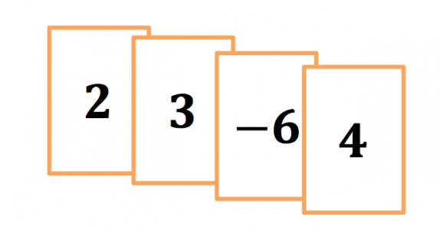  a. If all of the matching cards will increase her score by 18 , what are the matching  b. If all of the matching cards will decrease her score by 12 , what are the matching cards?  2. A hand of six integer cards has one matching set of two or more cards. If the matching set of cards is removed from the hand, the score of the hand will increase by six. What are the possible values of these matching cards? Explain. Write an equation using multiplication showing how the matching cards yield an increase in score of six. | 1. Create a real-life example that can be modeled by the expression −2×4 , and then state the product.  2. Two integers are multiplied and their product is a positive number. What must be true about the two integers? | Students determine whether or not various representations of the quotient of two integers are equivalent.  1. Mrs. McIntire, a seventh grade math teacher, is grading papers. Three students gave the following responses to the same math problem:  Student one: 1−2  Student two: −(12)  Student three: −12  On Mrs. McIntire’s answer key for the assignment, the correct answer is −0.5 . Which student answer(s) is (are) correct? Explain.  2. Complete the table below. Provide an answer for each integer division problem and write a related question using integer multiplication.  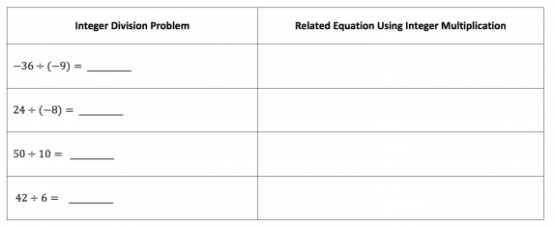 | 1. Write 3.0035 as a fraction. Explain your process.  2. This week is just one of 40 weeks that you spend in the classroom this school year. Convert the fraction 140 to decimal form | 1. What is the decimal value of 4/11?  2. How do you know that 4/11 is a repeating decimal?  3. What causes a repeating decimal in the long division algorithm?
Vocabulary | - Multiply  - Divide  - Integer  - Positive  - Negative  - Repeated addition  - Divisor  - Factor  - Decimal  - Product  - Quotient  - Subdivide  - Interval | - Multiply  - Divide  - Integer  - Positive  - Negative  - Repeated addition  - Divisor  - Factor  - Decimal  - Product  - Quotient  - Subdivide  - Interval | - Multiply  - Divide  - Integer  - Positive  - Negative  - Repeated addition  - Divisor  - Factor  - Decimal  - Product  - Quotient  - Subdivide  - Interval | - Multiply  - Divide  - Integer  - Positive  - Negative  - Repeated addition  - Divisor  - Factor  - Decimal  - Product  - Quotient  - Subdivide  - Interval | - Multiply  - Divide  - Integer  - Positive  - Negative  - Repeated addition  - Divisor  - Factor  - Decimal  - Product  - Quotient  - Subdivide  - Interval
Homework | Finish Problem Set | Finish Problem Set | Finish Problem Set | Finish Problem Set | Finish Problem Set

